

Model Development

IBM Developer

SKILLS NETWORK

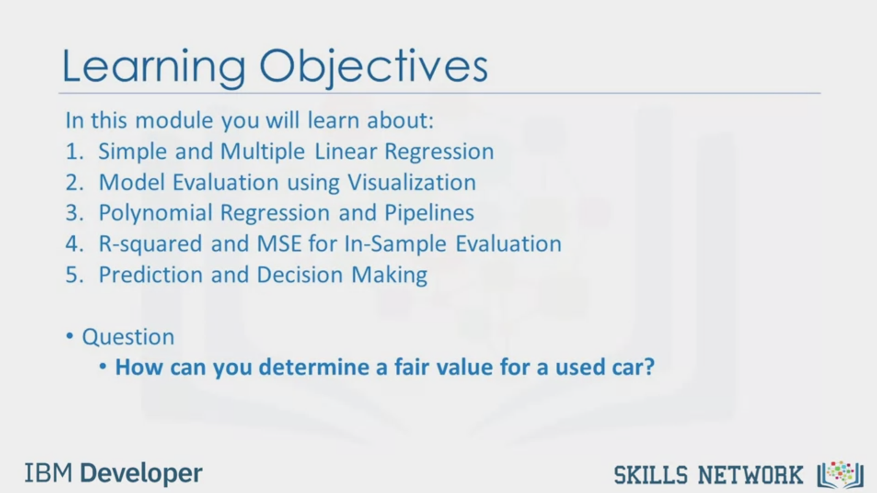

Learning Objectives

In this module you will learn about:

1. Simple and Multiple Linear Regression

2. Model Evaluation using Visualization

3. Polynomial Regression and Pipelines

4. R-squared and MSE for In-Sample Evaluation

5. Prediction and Decision Making

• Question

• How can you determine a fair value for a used car?

IBM Developer

SKILLS NETWORK

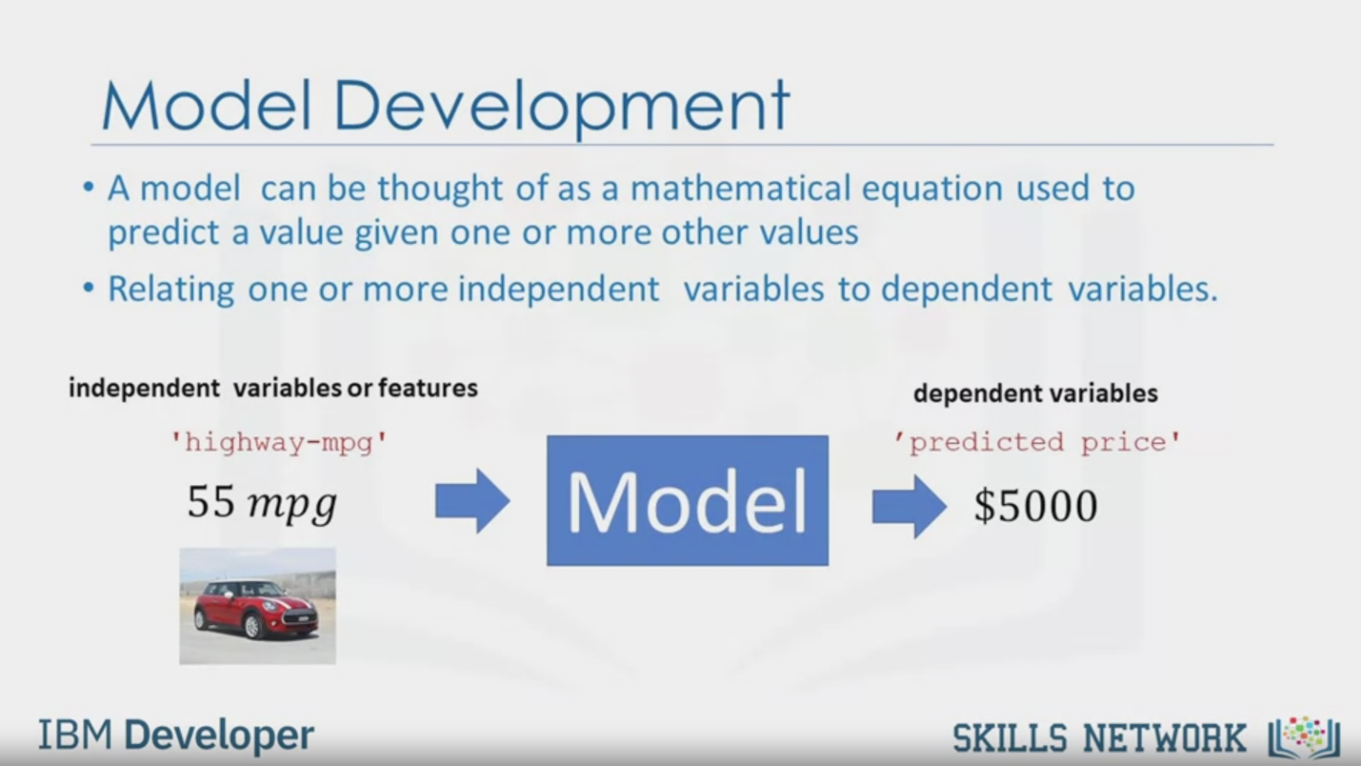

Model Development

• A model can be thought of as a mathematical equation used to

predict a value given one or more other values

• Relating one or more independent variables to dependent variables.

independent variables or features

dependent variables

'highway-mpg'

'predicted price'

55 mpg

Model

$5000

IBM Developer

SKILLS NETWORK

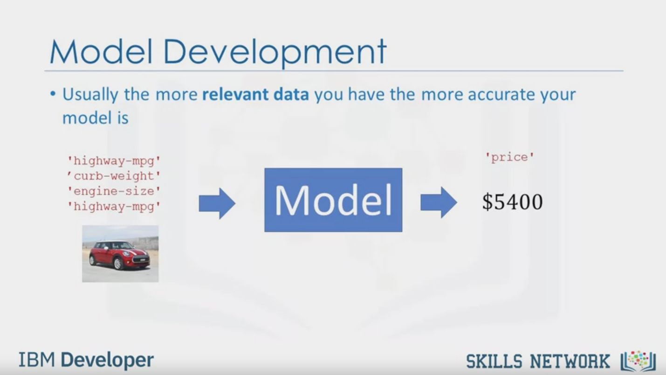

Model Development

• Usually the more relevant data you have the more accurate your

model is

'highway-mpg'

'curb-weight'

"engine-size'

'highway-mpg'

'price'

Model

$5400

IBM Developer

SKILLS NETWORK

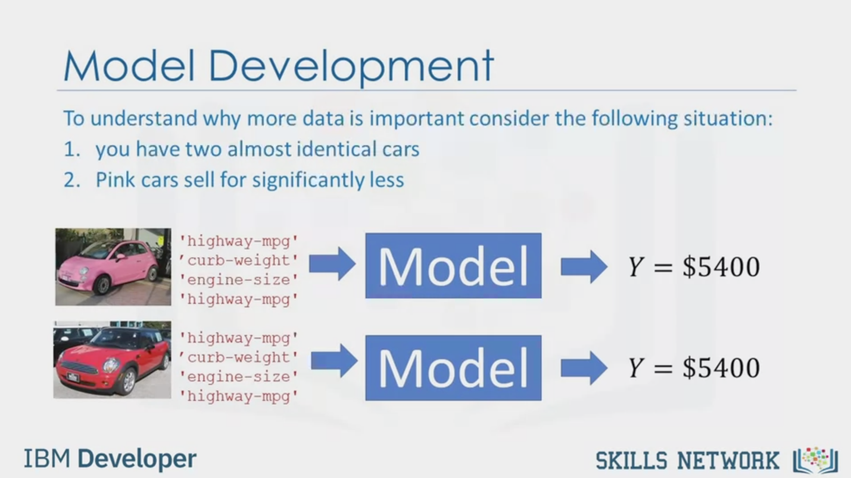

Model Development

To understand why more data is important consider the following situation:

1. you have two almost identical cars

2. Pink cars sell for significantly less

"highway-mpg'

" curb-weight'

"engine-size'

"highway-mpg'

Model

Y = $5400

"highway-mpg'

'curb-weight'

"engine-size'

"highway-mpg'

Model

Y = $5400

IBM Developer

SKILLS NETWORK

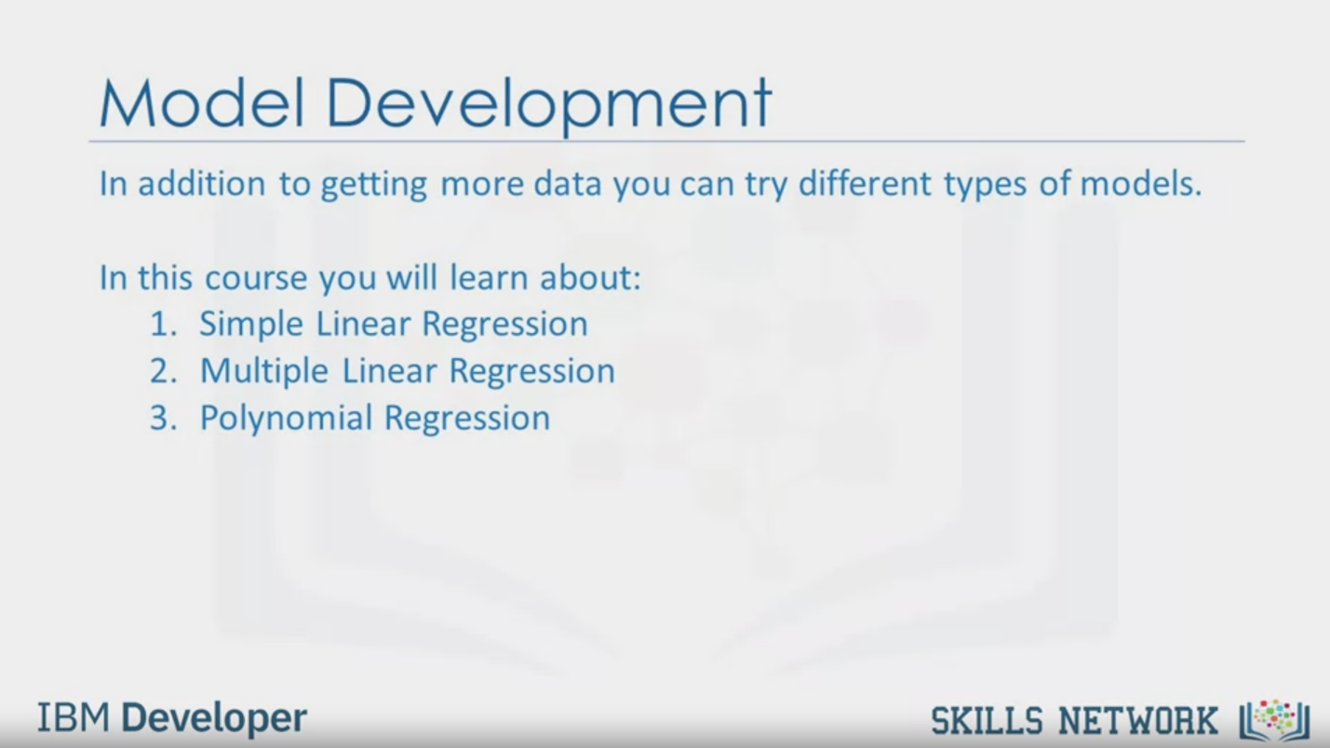

Model Development

In addition to getting more data you can try different types of models.

In this course you will learn about:

1. Simple Linear Regression

2. Multiple Linear Regression

3. Polynomial Regression

IBM Developer

SKILLS NETWORK



SKILLS NETWORK

IBM Developer

In this video we will examine

model development by trying to predict the price of a car using our dataset.

In this module, you'll learn about simple and multiple linear regression,

model evaluation using visualization,

polynomial regression and pipelines,

R-squared and MSE for in-sample evaluation,

prediction and decision making,

and how you can determine a fair value for a used car.

A model or estimator can be thought of as

a mathematical equation used to predict the value given one or more other values.

Relating one or more independent variables or features to dependent variables.

For example, you input a car model's

highway miles per gallon as the independent variable or feature,

the output of the model or dependent variable is the price.

Usually, the more relevant data you have,

the more accurate your model is.

For example, you input multiple independent variables or features to your model.

Therefore, your model may predict a more accurate price for the car.

To understand why more data is important,

consider the following situation.

You have two almost identical cars.

Pink cars sell for significantly less.

You want to use your model to determine the price of two cars,

one pink, one red.

If your models independent variables or features do not include color,

your model will predict the same price for cars that may sell for much less.

In addition to getting more data,

you can try different types of models.

In this course, you will learn about simple linear regression,

multiple linear regression and polynomial regression.